



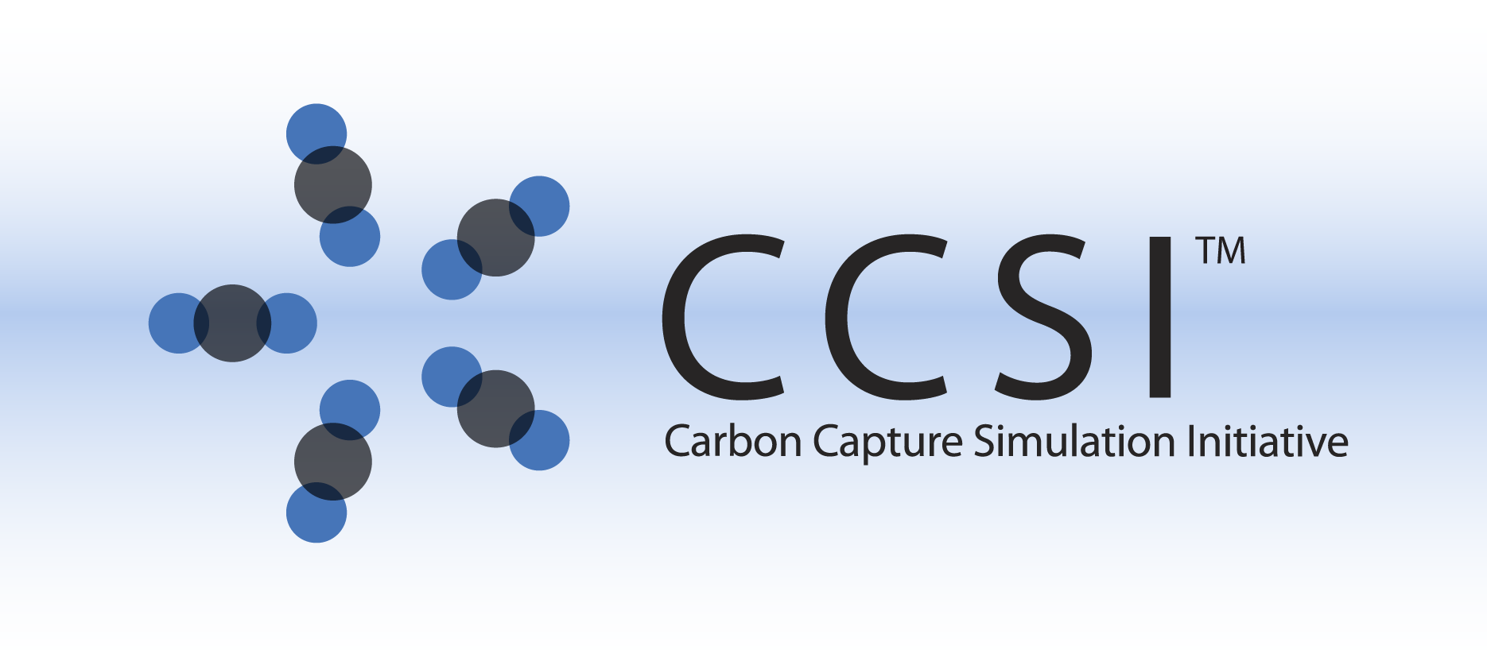

Bubbling Fluidized Bed Reactor Model

(BFB Reactor)

User Manual

Version 2.0.0

March 2018

Copyright (c) 2012 - 2018

**Copyright Notice**

BFB Reactor Model was produced under the DOE Carbon Capture Simulation Initiative (CCSI), and is copyright (c) 2012 - 2018 by the software owners: Oak Ridge Institute for Science and Education (ORISE), Los Alamos National Security, LLC., Lawrence Livermore National Security, LLC., The Regents of the University of California, through Lawrence Berkeley National Laboratory, Battelle Memorial Institute, Pacific Northwest Division through Pacific Northwest National Laboratory, Carnegie Mellon University, West Virginia University, Boston University, the Trustees of Princeton University, The University of Texas at Austin, URS Energy & Construction, Inc., et al.. All rights reserved.

NOTICE. This Software was developed under funding from the U.S. Department of Energy and the U.S. Government consequently retains certain rights. As such, the U.S. Government has been granted for itself and others acting on its behalf a paid-up, nonexclusive, irrevocable, worldwide license in the Software to reproduce, distribute copies to the public, prepare derivative works, and perform publicly and display publicly, and to permit other to do so.

**License Agreement**

BFB Reactor Model Copyright (c) 2012 - 2018, by the software owners: Oak Ridge Institute for Science and Education (ORISE), Los Alamos National Security, LLC., Lawrence Livermore National Security, LLC., The Regents of the University of California, through Lawrence Berkeley National Laboratory, Battelle Memorial Institute, Pacific Northwest Division through Pacific Northwest National Laboratory, Carnegie Mellon University, West Virginia University, Boston University, the Trustees of Princeton University, The University of Texas at Austin, URS Energy & Construction, Inc., et al. All rights reserved.

Redistribution and use in source and binary forms, with or without modification, are permitted provided that the following conditions are met:

1. Redistributions of source code must retain the above copyright notice, this list of conditions and the following disclaimer.
2. Redistributions in binary form must reproduce the above copyright notice, this list of conditions and the following disclaimer in the documentation and/or other materials provided with the distribution.
3. Neither the name of the Carbon Capture Simulation Initiative, U.S. Dept. of Energy, the National Energy Technology Laboratory, Oak Ridge Institute for Science and Education (ORISE), Los Alamos National Security, LLC., Lawrence Livermore National Security, LLC., the University of California, Lawrence Berkeley National Laboratory, Battelle Memorial Institute, Pacific Northwest National Laboratory, Carnegie Mellon University, West Virginia University, Boston University, the Trustees of Princeton University, the University of Texas at Austin, URS Energy & Construction, Inc., nor the names of its contributors may be used to endorse or promote products derived from this software without specific prior written permission.

THIS SOFTWARE IS PROVIDED BY THE COPYRIGHT HOLDERS AND CONTRIBUTORS "AS IS" AND ANY EXPRESS OR IMPLIED WARRANTIES, INCLUDING, BUT NOT LIMITED TO, THE IMPLIED WARRANTIES OF MERCHANTABILITY AND FITNESS FOR A PARTICULAR PURPOSE ARE DISCLAIMED. IN NO EVENT SHALL THE COPYRIGHT OWNER OR CONTRIBUTORS BE LIABLE FOR ANY DIRECT, INDIRECT, INCIDENTAL, SPECIAL, EXEMPLARY, OR CONSEQUENTIAL DAMAGES (INCLUDING, BUT NOT LIMITED TO, PROCUREMENT OF SUBSTITUTE GOODS OR SERVICES; LOSS OF USE, DATA, OR PROFITS; OR BUSINESS INTERRUPTION) HOWEVER CAUSED AND ON ANY THEORY OF LIABILITY, WHETHER IN CONTRACT, STRICT LIABILITY, OR TORT (INCLUDING NEGLIGENCE OR OTHERWISE) ARISING IN ANY WAY OUT OF THE USE OF THIS SOFTWARE, EVEN IF ADVISED OF THE POSSIBILITY OF SUCH DAMAGE.

You are under no obligation whatsoever to provide any bug fixes, patches, or upgrades to the features, functionality or performance of the source code ("Enhancements") to anyone; however, if you choose to make your Enhancements available either publicly, or directly to Lawrence Berkeley National Laboratory, without imposing a separate written license agreement for such Enhancements, then you hereby grant the following license: a non-exclusive, royalty-free perpetual license to install, use, modify, prepare derivative works, incorporate into other computer software, distribute, and sublicense such enhancements or derivative works thereof, in binary and source code form. This material was produced under the DOE Carbon Capture Simulation

Table of Contents

BFB Reactor Model 1

1.0 Abstract 1

2.0 Reporting Issues 1

3.0 Version Log 1

Bubbling Fluidized Bed (BFB) 2

1.0 Introduction 2

2.0 General Information 2

2.1 Overview 2

2.2 Model Assumptions 2

2.3 Liquid Density of Water 4

3.0 Model Structure 4

3.1 IO Structure and Reactor Dimensions 5

3.2 Run Mode Selectors 5

3.3 Component List and Physical Properties 7

3.4 Pressure Drop 7

3.5 Three-Region Mass and Energy Balances 8

3.6 Hydrodynamics 8

3.7 Heat Exchanger Model 8

4.0 Tutorial 9

4.1 Pre-Solved Cases 9

4.2 Model Inputs 10

4.3 ACM Implementation 15

4.4 gPROMS Implementation 19

5.0 Discretisation Study 25

5.1 Study Conditions 27

5.2 Summary 29

6.0 Changing Reaction Kinetics 30

7.0 Installation Requirements 31

8.0 References 31

List of Figures

Figure 1: BFB reactor model schematic. 2

Figure 2: Three-region structure mass transfer schematic. 8

Figure 3: Classification of the BFB models. 9

Figure 4: Model Forms menu in ACM. 15

Figure 5: Flowsheet LocalVariables in ACM. 16

Figure 6: Changing simulation run mode in ACM. 18

Figure 7: gPROMS explorer and flowsheet model. 19

Figure 8: gPROMS model parameter input. 20

Figure 9: gPROMS flowsheet variable input parameter specification interface. 21

Figure 10: gPROMS “Simulate” window. 23

Figure 11: gPROMS simulation results tree. 24

Figure 12: Dependence of CO2 removal on number of discretization points. 28

Figure 13: Dependence of predicted inlet pressure on number of discretization points. 29

List of Tables

Table 1: Device Variables 10

Table 2: Sorbent Parameters 11

Table 3: Gas Inlet Specification 12

Table 4: Heat Exchange Fluid Inlet Specification 12

Table 5: Solid Inlet Specification 12

Table 6: Model Parameters 13

Table 7: Equation Scaling Parameters 14

To obtain support for the products within this package, please send an e-mail to   
[ccsi-support@acceleratecarboncapture.org](mailto:ccsi-support@acceleratecarboncapture.org).

BFB Reactor Model

1. Abstract

Bubbling Fluidized Bed Reactor Model: A unified set of BFB models for various configurations in both steady-state and dynamic versions. This one-dimensional PDE process model is flexible, modular, and computationally efficient. It is suitable for process synthesis and design tasks aimed to facilitate the rapid screening of new concepts and technologies for carbon capture.

1. Reporting Issues

To report an issue, please send an e-mail to [ccsi-support@acceleratecarboncapture.org](mailto:ccsi-support@acceleratecarboncapture.org).

1. Version Log

| Product | Version Number | Release Date | Description |
| --- | --- | --- | --- |
| **Bubbling Fluidized Bed Reactor Model** | **2.0.0** | **3/31.2018** | **Initial Open Source release** |
| Bubbling Fluidized Bed Reactor Models | 2015.10.0 | 10/31/2015 | 2015 October IAB Release |
| Bubbling Fluidized Bed Reactor Models | 2015.6.0 | 07/07/2015 | 2015 June IAB Release |
| Bubbling Fluidized Bed Reactor Models | 2014.10.0 | 10/31/2014 | 2014 October IAB Release – First Revision |

Bubbling Fluidized Bed (BFB)

1. Introduction

This documentation introduces the steady-state solid sorbent Bubbling Fluidized Bed (BFB) Reactor Model that has been developed within the Carbon Capture Simulation Initiative (CCSI) to simulate the solid sorbent adsorption and regeneration units in carbon capture processes. This one-dimensional partial differential equation (PDE) process model is flexible, modular, and computationally efficient. The model is suitable for process synthesis and design tasks aimed to facilitate the rapid screening of new concepts and technologies for carbon capture. To run BFB simulations, AspenTech® 8.4 and gPROMS® (Process Systems Enterprise Limited) ModelBuilder 4.0 need to be installed on either Windows® or Linux® systems.

1. General Information
   1. Overview

A fluidized bed reactor is characterized by a bed of solid particles that move freely due to the drag force exerted by a working fluid. This reactor model is specifically applicable to the bubbling fluidization regime for a reactive solid-gas contacting fluidized bed device. In this regime the gas flow is large enough to maintain fluidization conditions in the bed of solid particles while forming distinct gas bubbles that travel across the bed. To describe this complex multi-phase behavior, the hydrodynamics and reactivity are defined within a one-dimensional, multi-region model structure. Figure 1 below shows a schematic of a BFB reactor with overflow solids outlet.

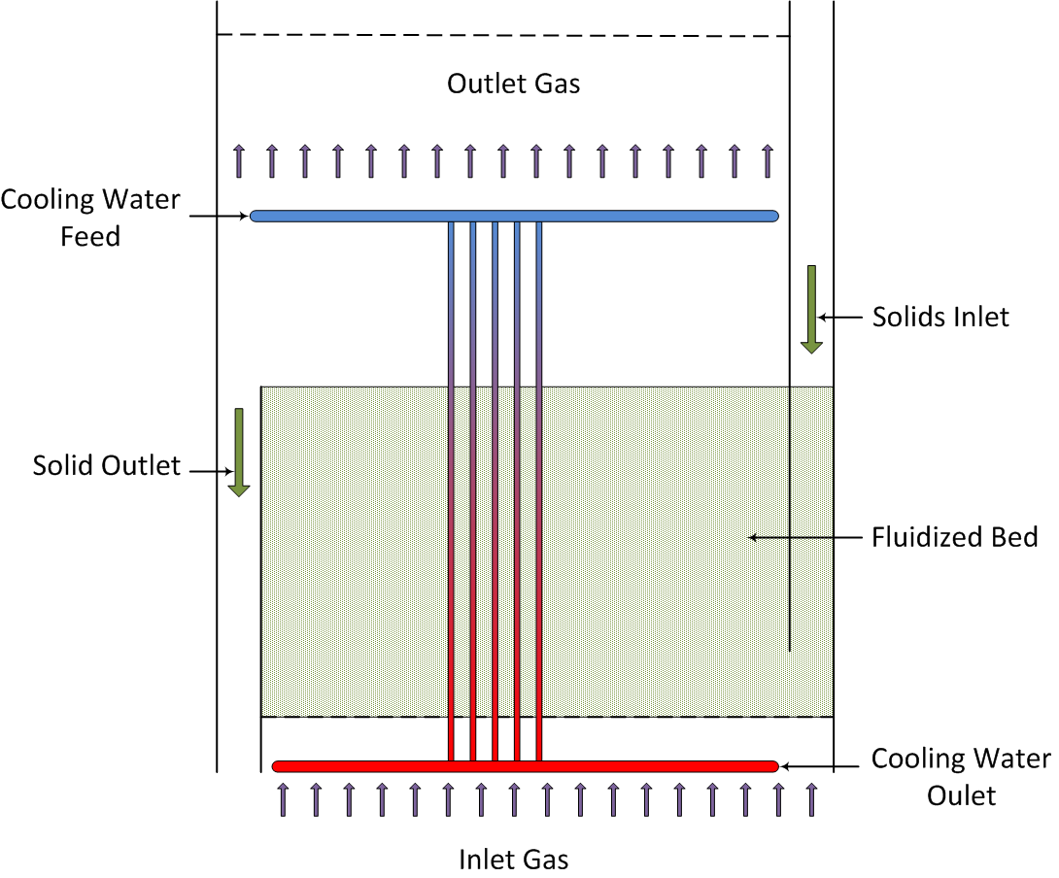

Figure : BFB reactor model schematic.

* 1. Model Assumptions

This first-of-a-kind implementation is the most comprehensive attempt to simulate BFB reactors to date that is not based on multi-dimensional, computationally expensive high fidelity approaches (i.e., computational fluid dynamics (CFD)). Therefore, many correlations are required to describe the governing transport phenomena and hydrodynamics. The main assumptions of the model are listed below:

* Constant bed depth
* Vertical shell and tubes type reactor
* Shell-side: Reactive gas and solid fluidized bed
* Tube-side: Heat exchanging medium
* Radial effects in the vessel are neglected
* Potential effects of reactions in the vessel freeboard are neglected
* BFB reactor is represented by a system of one-dimensional PDEs and algebraic expressions defined in the axial direction corresponding to the depth of the bed
* Three-region multi-phase structure with mass and energy transfer between regions
* Emulsion region: Gas and solid phases
* Cloud-wake region: Gas and solid phases
* Gas bubble region: Only gas, no solids present
* Properties and state variables are constant at each region for each slice of the discretized axial domain
* Pressure drop is characterized by the weight of the bed of solids
* Reaction rates in the solid phase are dictated by a kinetic model developed for   
  amine-impregnated mesoporous sorbents [1]
* Uniform solids temperature (no temperature profile within particles)
* Effects of particle attrition are ignored
* Applicable to steady-state operation, all time-dependent terms are set to zero
* Negligible variance in gas phase heat capacity between regions within the same slice of the discretized axial domain
* Only gas-phase mole fractions and temperatures have a significant time variant term in dynamic mass and energy balances

For a comprehensive description of the model equations please refer to the article by Lee and Miller [2].

* 1. Liquid Density of Water

In the Aspen Custom Modeler® (ACM, Aspen Technology, Inc.) implementation of the model, the   
Peng-Robinson equation of state with the Boston-Matthias alpha function is used for physical property calls. It has been determined that this equation of state gives incorrect values for the density of liquid water, which is used in the in-bed heat exchangers. To maintain consistency with previous versions of the models, the property calls for the liquid density of the heat exchanger fluid have been replaced with a hard coded correlation for the liquid density of water as a function of temperature. For users who wish to use a different heat exchanger fluid, these correlations will need to be replaced with either calls to a physical property package or a suitable correlation. This only affects the ACM implementation, and not the gPROMS implementation.

1. Model Structure

The developed model was implemented in both ACM and gPROMS and all partial-differential equations are solved using method of lines. The spatial domain has been discretized using a 1st order backward finite difference method with the option to choose between uniform, two stage and adaptive discretization schemes and 74 elements are used as a default. A study of the alternative discretization schemes and the dependence of the results upon the number of discretization points used is presented in Section 5.0 Discretisation Style. The ACM and gPROMS files include newly-defined parameter, port, and variable types that complement the reactor model.

In ACM, the code for the model equations can be found in the Custom Modeling library:

1. In the “All Items” pane of the “Explorer – Simulation” window, locate the “Custom Modeling library” and then expand the window to view the contents.
2. Expand the “Models” sub-folder and then click “BFB.”
3. In the “Contents” pane, located below the “All Items” pane, double-click “BFB” to view the model code.

In gPROMS, the code for the model equations can be found in the Models library:

1. In the “Projects” pane on the left side, select the current model and then expand the model to view all of the contents.
2. Expand the “Models” sub-folder and then double-click “BFB.” A window for the “BFB Model” displays.
3. At the bottom of the “BFB Model” window, click the “gPROMS language” tab to view the model code.
   1. IO Structure and Reactor Dimensions

This reactor model contains several input and output ports. Each port has associated variables that correspond to the material connection stream variables.

In ACM, the inlet and outlet ports for gas and heat exchanging fluid are defined using the default “MainPort” port type; Solid inlet and outlet ports are defined by the tailored port type “SorbentPort” which is defined by the mass flowrate, temperature, and loading of each adsorbed species.

In gPROMS, all port types are specified and tailored by users; Gas inlet and outlet ports are defined by the port type “GasPort” which is defined by the molar flowrate, temperature, pressure, and molar fraction of each gas species; Heat exchanging fluid inlet and outlet ports are defined by the port type “HXPort” which is defined by the molar flowrate, temperature, pressure, molar specific enthalpy, and molar fraction of each fluid species; Solid inlet and outlet ports are defined by the port type “SorbentPort” which is defined by the mass flowrate, temperature, pressure, and loading of each adsorbed species.

Given the equation oriented nature of this implementation, this model can be used to perform either rating or design calculations as long as the corresponding variables are specified as fixed to satisfy the degrees of freedom required for the solution.

* 1. Run Mode Selectors

The BFB model includes five Run Mode selectors which allow the user to modify the complexity of the model to suit their purposes. These selectors generally provide a trade-off between accuracy and complexity and give the user the ability to simplify sections of the model to improve the performance and reliability of the model if necessary. Each of the available Run Mode selectors are discussed below.

RM_Discretization

This Run Mode selector allows the user to select between three different discretization schemes for the axial domain (more details are available in Section 5.0 Discretisation Style). The options available are:

* *Uniform* – all discretized slices have the same length. This is the simplest discretization scheme but also the least accurate.
* *2 Stage* – the domain is divided into two sections with different discretization lengths in each section. This allows the user to have a greater number of discretization points in the part of the domain where derivatives are greatest (generally the lower portion of the bed), improving accuracy whilst reducing the number of discretization points in the remainder of the domain. Properly configured, this method provides a significant improvement in accuracy for a very small increase in complexity.
* *Adaptive* – the length of each discretized slice is inversely proportional to the spatial derivative of CO2 in the bubble region gas phase. This automatically increases the number of discrete points in regions where derivatives are greatest, improving the accuracy of the model. However, the length of each discrete slice must now be solved as part of the model increasing the complexity of the model.

RM_HXMethod

This Run Mode selector allows the user to specify the specific heat exchanger fluid used in the internal heat exchangers and the method used to calculate the relevant physical properties of the fluid. Currently the model includes four options. **Note:** The “Condensing” option calculates the required flowrate of HX fluid whilst the other options require the flowrate as an input.

* *Rigorous* – this option provides a general solution for the heat exchanger fluid using flash calculations performed by the inbuilt properties package. This combination allows for any HX fluid specified in the “hexlist” component list and allows for phase changes in the fluid. However, this option makes extensive use of the physical properties package, which increase computational overhead. **Note:** In the ACM implementation, the liquid density of the heat exchanger fluid is calculated using a correlation for liquid water rather than a property call, as discussed in Section 2.3 Liquid Density of Water.
* *Condensing* – this option assumes that the HX fluid is initial in the vapor phase and that all the heat provided to the fluidized bed is due to condensation of the fluid. The fluid is assumed to remain at the saturation temperature determined at the inlet pressure of the fluid (changes in pressure are neglected) throughout the heat exchanger tubes and to leave the system as saturated liquid (100% condensation). Physical property calls are required only at the inlet and outlet, which reduces the computational overhead. **Note:** This option is unique in that the flowrate of HX fluid is calculated based on the assumption of 100% condensation, whereas all other options require the flowrate to be specified. If this is not corrected the model will not solve, with ACM reporting that the model is over-specified, and gPROMS reporting that the model is not well posed.
* *Liquid* – the HX fluid is assumed to be in the liquid state and that no vaporization of the fluid will occur. Physical properties are calculated using the internal physical properties package, thus this method can be used for any HX fluid specified in the “hexlist”component list, as long as vaporization does not occur. This optional allows the use of simpler enthalpy calculations in place of the more complex flash calculations required by the Rigorous method. **Note:** In the ACM implementation, the liquid density of the heat exchanger fluid is calculated using a correlation for liquid water rather than a property call, as discussed in Section 2.3 Liquid Density of Water.
* *Water* – similar to the *Liquid* option, however the physical properties are calculated using algebraic correlations specific for pure water. This reduces computational overhead by not invoking the physical properties package, and provides analytical derivatives for the properties which can improve performance.

RM_MBalance

This Run Mode selector allows users performing steam-state simulations to use a simpler and more flexible expression in place (*Simplified* mode) of the rigorous bubble region total gas balance (*Rigorous* mode). This is not applicable for dynamic simulations as this formulation leaves the temporal derivative of the bubble region total gas phase concentration undefined.

RM_PhysProp

This Run Mode selector allows the user to elect to use either the in-built physical properties package (*Rigorous* mode) or a set of algebraic correlations (*Simplified* mode) to calculate a number of physical properties within the model. Utilizing *Rigorous* mode provides the most accurate result, however the *Simplified* mode has the advantages of reduced computational overhead and providing analytical derivatives for the physical properties which should improve performance and reliability.

RM_SmoothIF

This Run Mode selector provides the user with the option to replace a number of IF statements within the model with Smoothed Maximum approximations. The Smoothed Maximum approximation has the advantages of removing discontinuities and structural changes within the model, which improves performance and reliability and reduces run times, but also introduces some error into the system, especially at conditions close to the switching point of the IF statement. The smoothness and accuracy of the Smoothed Maximum approximation can be controlled through the “SmoothIF_eps” variable, with larger values increasing smoothness at the cost of greater error (Default Value = 1x10-4).

* 1. Component List and Physical Properties

Three gaseous species, carbon dioxide (CO2), water (H2O), and nitrogen (N2) are used in the gas phase. Three species, bicarbonate (Bic), carbamate (Car), and physisorbed water (H2O) are assumed to exist in the solid phase, adsorbed onto the sorbent. The mechanism of the adsorption of the adsorbate, CO2 and H2O, onto an amine-impregnated mesoporous sorbent is defined according to Lee et al., 2011.

Physical properties of the fluids can be calculated using commercial property packages (Aspen Properties® in ACM and Multiflash® in gPROMS) using cubic equations of state. The sorbent properties should be specified by the user. Particle diameter, density, sphericity, minimum fluidization voidage, heat capacity, and heat conductivity are essential. Additionally, a fines fraction can be specified but has limited effect on the model results.

* 1. Pressure Drop

The pressure drop is attributed to the weight of the solid bed. All other potential contributions are assumed to be negligible in comparison. It has been assumed that the pressure drop across the distributor plate located at the gas inlet (the bottom boundary of the discretized axial domain) is equal to the greater of 20% of the pressure drop across the bed or 0.034 bar.

* 1. Three-Region Mass and Energy Balances

In a BFB, the bulk of solids within the bed exist in a dense, fluidized emulsion region. At the bottom of the bed, gas bubbles are formed as the inlet gas crosses the distributor plate. These bubbles rise upwards through the bed carrying with them a surrounding cloud and a wake of gas and solids. Figure 2 shows a diagram for the gas and solid material balances as defined in this model for a differential slice *i* of the bed depth domain.



Figure : Three-region structure mass transfer schematic.

The axial mass and energy fluxes are defined by the plug flow of material for each region. At each differential axial slice, mass balance equations were defined for each phase (gas and solid) and region (bubble, cloud-wake, and emulsion) according to Figure 2 above. In an equivalent fashion, energy balances were defined accounting for the heat transfer provided by the internal heat exchange tubes. For the purposes of mass and energy balances the reaction between gas and solids is assumed to take place in the solid phase, such that the reaction conditions are those of the solids and any heat of reaction is applied to this phase.

* 1. Hydrodynamics

The performance of the BFB reactor is characterized by the size and velocity of the rising bubbles. This model implementation includes detailed correlations for these parameters as a function of bed depth for different types of particles.

* 1. Heat Exchanger Model

The model includes equations to predict the transfer of heat between the fluidized bed of solids and a set of heat exchanger tubes immersed within the bed. The current model contains equations for a single pass of the heat exchanger fluids with the fluid inside the immersed heat exchange tubes traveling in the opposite direction to the gas bubbles. The heat transfer model considers heat exchange between the gas and solids in the bed and the tubes.

1. Tutorial

This section provides detailed tutorials to simulate the performance of adsorber and regenerator units using the BFB model. These tutorials were developed using ACM v8.4 with Aspen Properties and gPROMS v4.0.0 with Multiflash v4.3 – modifications could be required when using different versions.

* 1. Pre-Solved Cases

Due to the complexity of the BFB model, it can often be difficult to achieve an initial solution for the model from a blank state. Thus, a number of pre-solved cases have been prepared to provide a starting point for users in developing models of their systems. Pre-solved cases have been prepared using both ACM and gPROMS for both single beds and two beds in series, with cases for adsorption and regeneration, as well as both overflow and underflow outlets. The directory structure used to store the   
pre-solved cases is shown below in Figure 3.

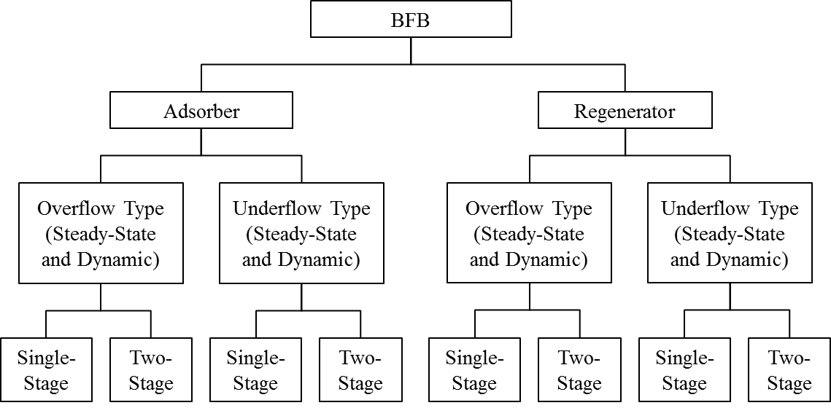

Figure : Classification of the BFB models.

* 1. Model Inputs

The BFB model has a number of input parameters that describe the system that the user needs to provide to obtain a meaningful result. These parameters can be divided into five categories; Device, Sorbent, Stream, Model, and Equation Scaling. A list of model input parameters is given below, along with a default value used in preparing the model.

Device Parameters

Device parameters describe the size and configuration of the reactor, and should be adjusted to match the system to be studied.

Table : Device Variables

| Parameter | Adsorber | Regenerator | Description |
| --- | --- | --- | --- |
| dPhx | 0.01 | 0.01 | Heat Exchanger Tube Pressure Drop (bar/m) |
| Dt | 12.8 | 9.6 | BFB Unit Diameter (m) |
| dx | 0.05 | 0.075 | Heat Exchanger Tube Diameter (m) |
| Lb | 1.2 | 3.6 | Bed Depth (m) |
| lhx | 0.04 | 0.04 | Heat Exchange Tube Spacing (m) |
| nor | 2,500 | 2,500 | Number of Orifices in Distributor Plate (1/m2) |
| SIType | Top/Bottom | | Solid Inlet Type (Top or Bottom) |
| SOType | Overflow/Underflow | | Solid Outlet Type (Overflow or Underflow) |
| wthx | 0.003 | 0.003 | Heat Exchanger Tube Wall Thickness (m) |

Sorbent Parameters

Sorbent parameters describe the characteristics of the solid sorbent to be used in the reactor, and include both the physical properties of the solids (e.g., particle size and density) and parameters describing the adsorption kinetics and equilibrium.

Table : Sorbent Parameters

| Parameter | Value | Description |
| --- | --- | --- |
| A1 | 0.17583 | Arrhenius Constant for Water Physisorption (mol/m3/Pa/K/s) |
| A2 | 0.091098 | Arrhenius Constant for Bicarbonate Formation (1/Pa/K/s) |
| A3 | 141.994 | Arrhenius Constant for Carbamate Formation (1/Pam1/K/s) |
| dH1 | -72,580.3 | Heat of Reaction for Water Physisorption (J/mol) |
| dH2 | -77,079.0 | Heat of Reaction for Bicarbonate Formation (J/mol) |
| dH3 | -109,691 | Heat of Reaction for Carbamate Formation (J/mol) |
| dS1 | -141.425 | Reaction Entropy for Water Physisorption (J/mol/K) |
| dS2 | -216.244 | Reaction Entropy for Bicarbonate Formation (J/mol/K) |
| dS3 | -281.255 | Reaction Entropy for Carbamate Formation (J/mol/K) |
| E1 | 29,622.8 | Activation Energy for Water Physisorption (J/mol) |
| E2 | 83,173.5 | Activation Energy for Bicarbonate Formation (J/mol) |
| E3 | 27,522.3 | Activation Energy for Carbamate Formation (J/mol) |
| M3 | 1.00 | Non-Ideality Exponent for Carbamate Formation Reaction |
| nv | 1,900.46 | Amine Loading of Sorbent (mol/m3) |
| cps | 1.13 | Particle Heat Capacity (kJ/kg/K) |
| dp | 1.5x10-4 | Particle Diameter (m) |
| emf | 0.5 | Bed Voidage at Minimum Fluidization Velocity |
| F | 0 | Fines Fraction (<45 micron) of Solids |
| kp | 1.36 | Particle Conductivity (J/m/K/s) |
| phis | 1.0 | Particle Sphericity |
| rhos | 442 | Particle Density (kg/m3) |

Stream Parameters

Stream parameters describe the conditions of the streams entering (or occasionally exiting) the reactor. There are three pairs of streams in the model; the gas inlet and outlet, the solid inlet and outlet, and the heat exchanger fluid inlet and outlet. In general, all the inlet conditions should be specified in the model, however it is possible in some cases to specify outlet conditions in place of the relevant inlet conditions.

In the presolved cases, inlet flowrates of gas and solids are determined by valves with specified valve coefficients. These valve coefficients were determined to meet nominal inlet flowrates of gas and solids, which are given in Tables 3–5 below.

Table : Gas Inlet Specification

| Parameter | Adsorber | Regenerator | Units |
| --- | --- | --- | --- |
| Flowrate* | 15,203.1 | 1,284 | kmol/hr |
| Pressure | 1.8 | 2.0 | bar |
| Temperature | 51.0 | 146.7 | °C |
| CO2 Mole Fraction | 0.130 | 0.787 |  |
| H2O Mole Fraction | 0.055 | 0.213 |  |
| N2 Mole Fraction | 0.815 | 1.0x10-3 |  |

Table : Heat Exchange Fluid Inlet Specification

| Parameter | Adsorber | Regenerator | Units |
| --- | --- | --- | --- |
| Flowrate | 98,000 | 6,835 | kmol/hr |
| Pressure | 1.12 | 6.9 | bar |
| Temperature | 33 | 170 | °C |
| CO2 Mole Fraction | 0 | 0 |  |
| H2O Mole Fraction | 1 | 1 |  |
| N2 Mole Fraction | 0 | 0 |  |

Table : Solid Inlet Specification

| Parameter | Adsorber | Regenerator | Units |
| --- | --- | --- | --- |
| Flowrate* | 1,240,000 | 1,850,000 | kg/hr |
| Pressure | 1.5 | 1.5 | bar |
| Temperature | 64 | 145 | °C |
| Bicarbonate Loading | 7.6x10-4 | 7.6x10-4 | mol/kg sorbent |
| Carbamate Loading | 0.557 | 1.995 | mol/kg sorbent |
| Water Loading | 0.012 | 0.401 | mol/kg sorbent |

**\*** = Nominal flowrate

Model Parameters

Model parameters include a number of parameters associated with the model, including empirical parameters used in correlations within the model, as well as parameters associated with the discretization of the model. Users should be cautious of changing these parameters without reason, as they have been assigned values based on experimental studies and can have a significant effect on the behavior of the model.

Table : Model Parameters

| Parameter | Value | Description |
| --- | --- | --- |
| ah | 0.8 | Empirical Factor in Heat Transfer Model |
| Cr | 1.0 | Correction Factor for Heat Exchanger |
| Disc_Adpt_Wgt | 1400 | Adaptive Discretization Weighting Factor |
| Disc_Split_Frac | 0.51 | 2-Stage Discretization Split Fraction |
| Disc_Split_Loc | 0.22 | 2-Stage Discretization Split Location |
| fw | 0.2 | Wake to Bubble Regions Volume Ratio |
| hw | 1.5 | Heat Exchanger Tube Wall Heat Transfer Coefficient (kJ/m2/K/s) |
| Kd | 100 | Gas Phase Bulk Flow Coefficient (m3/s) |
| ND | 102 | Number of Discretization Points |
| SmoothIF_eps | 1x10-4 | Smoothing parameter for Smooth Maximum approximation |
| Tref | 0 | Thermodynamic Reference Temperature (°C) |

Equation Scaling Parameters

Due to the need to specify fixed tolerances for the numerical solvers, equations involving very large or very small values can be difficult to accurately solve. To improve the accuracy and reliability of the model, scaling parameters have been added to key equations in the model to keep equation terms as close to order of magnitude 1 as possible. Due to variability in parameters associated with kinetic reactions it is often necessary to adjust the values of these scaling factors, thus the following parameters have been made available for users to adjust if necessary. In general, the value of the scaling parameters should be set such that the scaled variable (variable multiplied by its scaling factor) is as close to order of magnitude 1 across the full range of the model as is possible. If users are having problems with model convergence, and in the absence of better information, it is suggested that these parameters be set to “1.”

Table : Equation Scaling Parameters

| Parameter | Adsorber | Regenerator | Description |
| --- | --- | --- | --- |
| k1sf | 1,000 | 1,000 | Rate constant 1 scaling factor |
| k2sf | 1x1011 | 1x1010 | Rate constant 2 scaling factor |
| k3sf | 1 | 1 | Rate constant 3 scaling factor |
| Ke1sf | 100 | 1,000 | Equilibrium constant 1 scaling factor |
| Ke2sf | 100,000 | 1x106 | Equilibrium constant 2 scaling factor |
| Ke3sf | 10,000 | 100,000 | Equilibrium constant 3 scaling factor |
| r1csf | 1 | 10 | Cloud-Wake reaction 1 rate scaling factor |
| r1esf | 100 | 10 | Emulsion reaction 1 rate scaling factor |
| r2csf | 1x106 | 1,000 | Cloud-Wake reaction 2 rate scaling factor |
| r2esf | 1x106 | 1,000 | Emulsion reaction 2 rate scaling factor |
| r3csf | 1,000 | 10,000 | Cloud-Wake reaction 3 rate scaling factor |
| r3esf | 100,000 | 100,000 | Emulsion reaction 3 rate scaling factor |

* 1. ACM Implementation

Accessing Model Inputs

Most model inputs can be accessed via forms associated with the model instances within the ACM flowsheet. Right-clicking a model within the “Process Flowsheet Window” brings up a drop-down menu of options for that model. Selecting the “Forms” option brings up a menu of predefined forms for the model which includes a number of forms for entering inputs and examining results, as show in Figure 4.

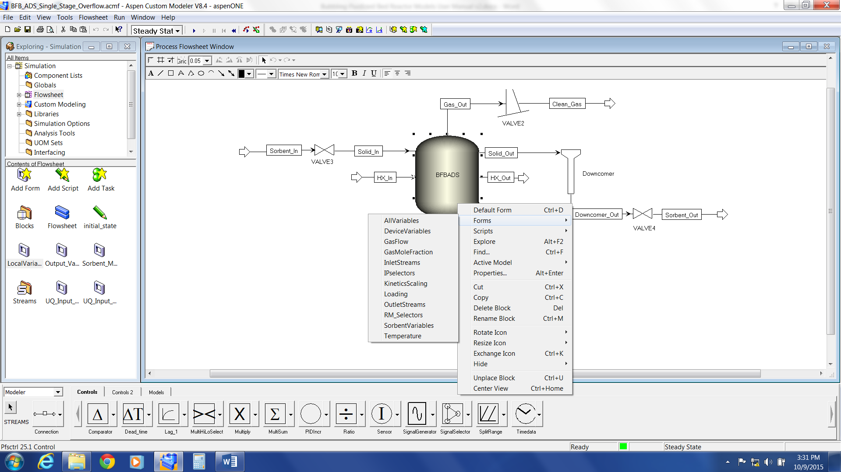

Figure : Model Forms menu in ACM.

For the BFB reactor model, the following forms contain model inputs:

1. *DeviceVariables* – contains all Device Parameters, plus a number of calculated variables relating to the design of the reactor
2. *InletStreams* – contains all Stream Parameters
3. *KineticsScaling* – contains all Equation Scaling Parameters
4. *RM_Selectors* – contains model Run Mode Selectors
5. *SorbentVariables* – contains all Sorbent Parameters, plus some calculated variables concerning particle behavior

In the presolved cases, especially the two bed examples, some parameters are specified at the overall flowsheet level to ensure they are the same in all models. To access these parameters, navigate to the “Exploring” pane, click “Flowsheet,” and then double-click “LocalVariables” in the “Contents” pane, as shown in Figure 5.

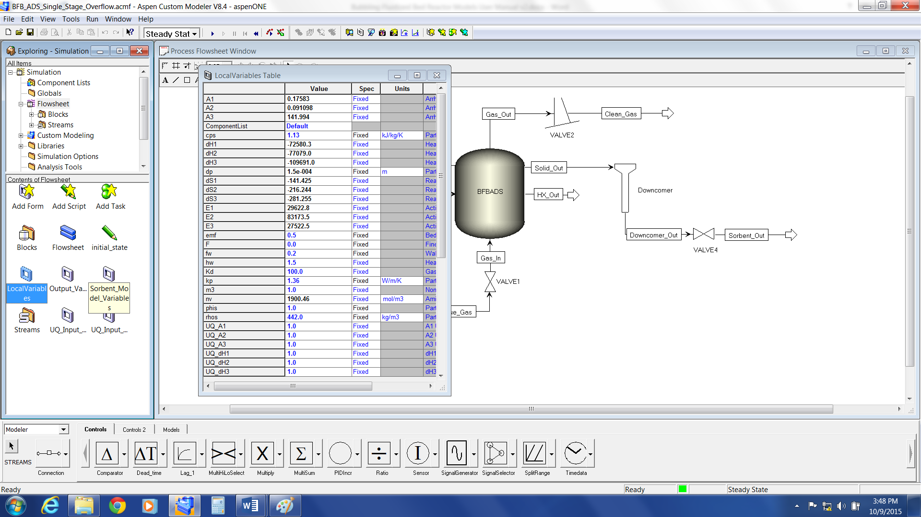

Figure : Flowsheet LocalVariables in ACM.

Any entry described as “Fixed” (the third column of the form) is a model input that can be varied. To enter a new value for a parameter, select the current value of the parameter and then enter the new value.

Parameter and variable values for models and streams can also be accessed by double-clicking the desired model or stream in the “Flowsheet” pane, which opens a default form for that model or stream.

Model Initialization

Due to the complexity of the model equations, it is necessary to initialize the model to successfully obtain a solution. The presolved cases have already been initialized and can be used as a starting point for further simulations. It is recommended to start from one of these simulations when developing cases, as it can be difficult to initialize the model from its default state. Additional reactors can be added by copying an existing model within the flowsheet which will be initialized with the current state of that model.

In cases where it is not possible to use an existing, preinitialized model, the BFB model comes with two initialization scripts to initialize the model from its default state. These work by starting with a simplified form of the model and gradually adding complexity until the full model is solved. Due to differences in the behavior of the model under adsorption and regeneration conditions, there are initialization scripts for both conditions, which differ in the order in which complexity is added.

It is also important to note that the initialization can be extremely sensitive to the operating conditions being used, and that it may be necessary to adjust the initialization procedures in these cases. This requires an understanding of ACM scripting in addition to the model code, and the user is directed to the ACM User Manuals for more information on this topic. It is for this reason that it is recommended to work from a solved case of the model wherever possible.

To access the initialization scripts, right-click the model to be initialized in the “Flowsheet” pane and then select “Scripts” from the drop-down menu. Left-click either “IPsolveADS” (for adsorption conditions) or “IPsolveRGN” (for regeneration conditions) and the script initializes that model. **Note:** This requires solving the model multiple times, and may take a number of minutes to complete.

To improve the chances of successfully initializing the model, it is suggested to use Run Mode Selectors to simplify the model prior to initializations. The suggested settings are:

* *RM_HXMethod* – either *Condensing* or *Liquid* depending on the state of the HX fluid. **Note:** When using *Condensing* the flowrate of the HX fluid must be set to a free variable by   
  double-clicking the “HX Fluid Inlet” stream and then setting “F” to a free variable.
* RM_MBalance – Simplified
* RM_PhysProp – Simplified
* RM_SmoothIF – On

Once the model has been successfully initialized, the Run Mode Selectors can be returned to the user’s desired settings. If the user is still having difficulty initializing the model, check the Equation Scaling Parameters and set them all to “1.”

Running Simulations

In ACM, the run mode of a simulation can be changed via the drop-down list in the menu bar above the “Flowsheet” pane, as shown in Figure 6. If the model is properly specified and all degrees of freedom are met, then a green square displays in the lower right of the program window and the “Run Simulation” button (the blue arrow immediately to the right of the simulation mode drop-down menu) is available. Clicking the blue arrow runs the simulation using the current simulation mode, and on completion, a   
pop-up box displays with a message about whether the simulation converged or not.

For dynamic simulations, it is also necessary to specify a simulation duration and any scheduled events that are to occur during the simulation. Simulation duration, as well as time steps and reporting intervals, can be changed through the “Run Options” button in the menu bar (). Scheduled events can be setup by creating “Tasks” under the “Flowsheets” tab in the “Exploring” pane. A number of simple example tasks, consisting of ramp changes in input conditions, have been provided in the presolved examples. To activate or deactivate a task, double-click the relevant “Task” icon in the “Contents” pane – a “lightning bolt” icon indicates that a task is active.

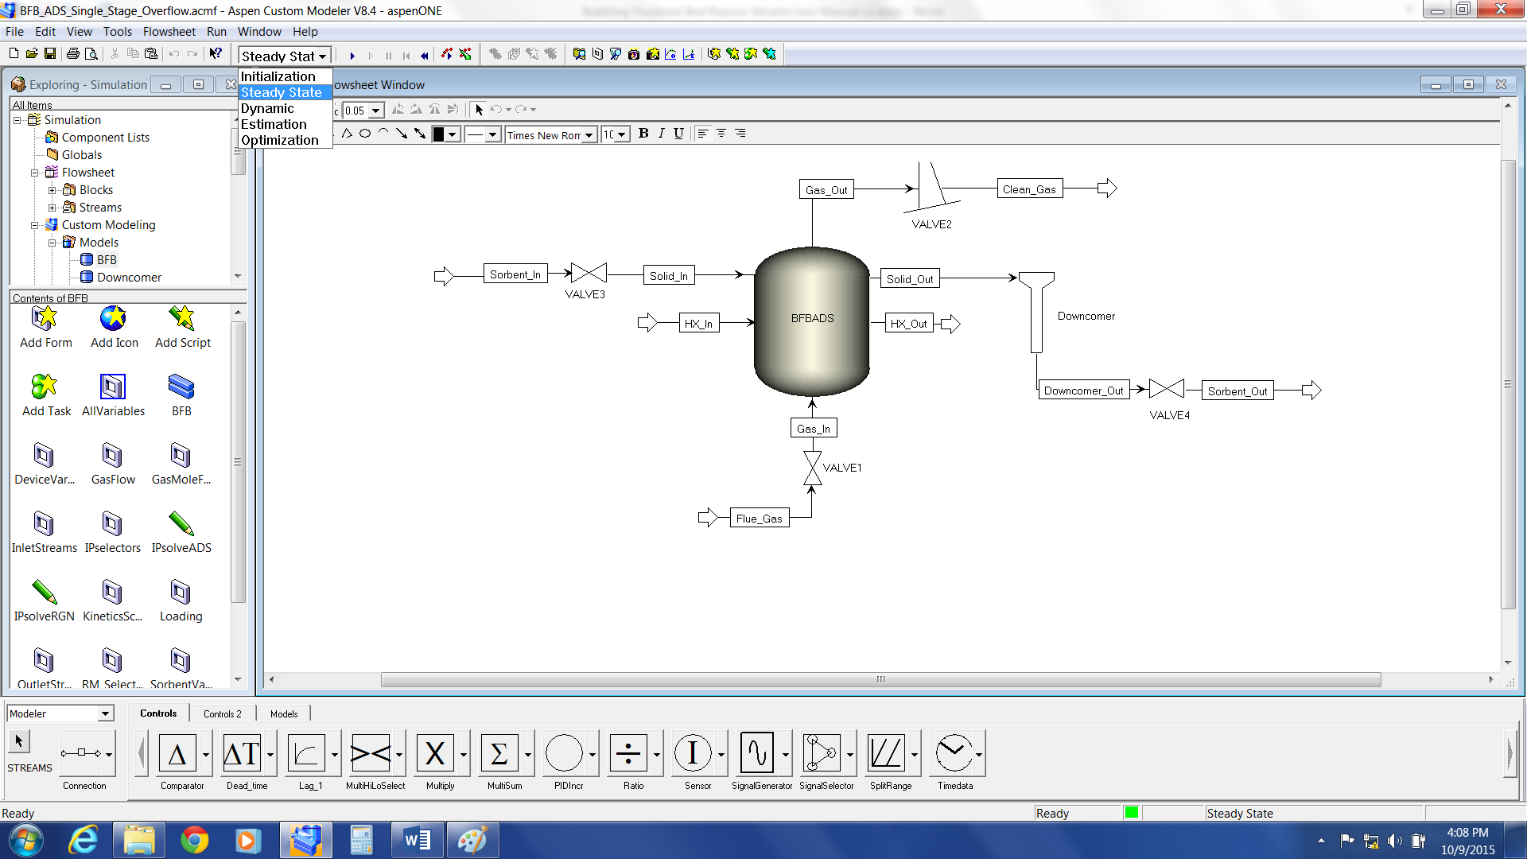

Figure : Changing simulation run mode in ACM.

Reviewing Results

Once a simulation has successfully converged, the results can be reviewed in a number of ways. A number of predefined *Forms*, similar to those used for mode inputs, are available to review key results. These include a number of pre-generated plots of key variables across the depth of the fluidized bed, such as temperature, concentration, and loading profiles. Details of outlet streams can be accessed by   
double-clicking the relevant stream on the “Flowsheet”pane. More detailed information on the internal behavior of the reactor can be accessed via the “AllVariables” form, by double-clicking the “Reactor” icon in the “Flowsheet” pane. **Note:** For plots along the axial domain of the model, results will often be presented in terms of discretization point rather than bed depth, which may result in apparent discontinuities in the plots when using non-uniform discretization schemes. The pre-generated *Forms* are all plotted against bed depth rather than discretization point for convenience.

* 1. gPROMS Implementation

Accessing Model Inputs

To access the model input variables in gPROMS, expand the “Models” branch in the simulation tree in the left pane of the “gPROMS” window. Next, double-click the “Flowsheet”object to open the model flowsheet and then select the “Topology” tab, as shown in Figure 7.

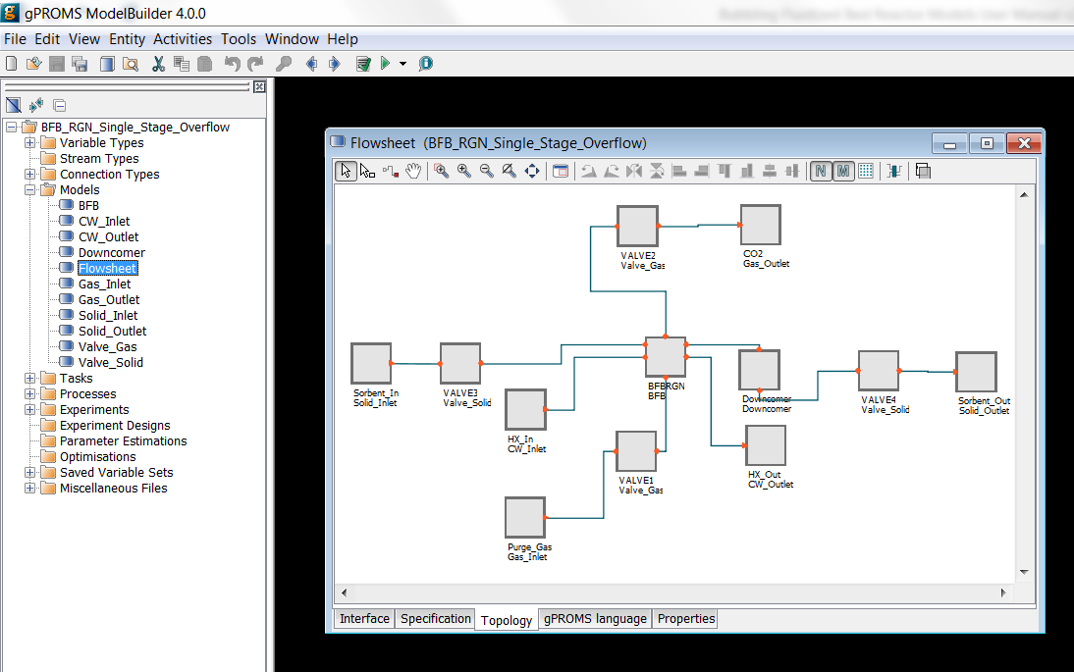

Figure : gPROMS explorer and flowsheet model.

Model inputs can be accessed by double-clicking the relevant entities in the model to display a list of inputs for that entity. For example, double-clicking a reactor entity in the “Flowsheet”displays the window shown in Figure 8. Entries without a checkmark in their check box are not inputs for the model in the current setup and can be ignored (generally these are global parameters specified at the flowsheet level). The value of an input can be changed by simply entering a new value in the box beside the variable name, or selecting a value from the drop-down list.

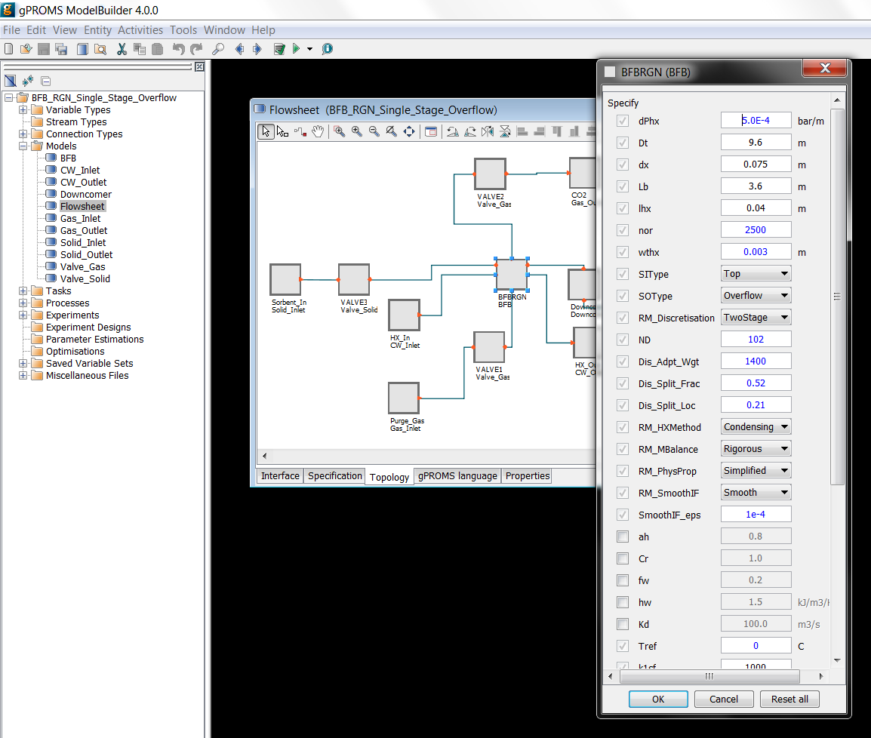

Figure : gPROMS model parameter input.

For global parameters specified at the flowsheet level, navigate to the “Interface” tab of the “Flowsheet” window and then click the “Edit Specification” button, as shown in Figure 9. In the “Public Model Attributes” pane (the top right of the window), double-click the row associated with the parameter the user wished to change to open a dialogue box, enter the desired value for the parameter in the “Default value” box, and then click “OK”. Once the user has finished specifying parameters, click “Finish” in the lower right of the pane.

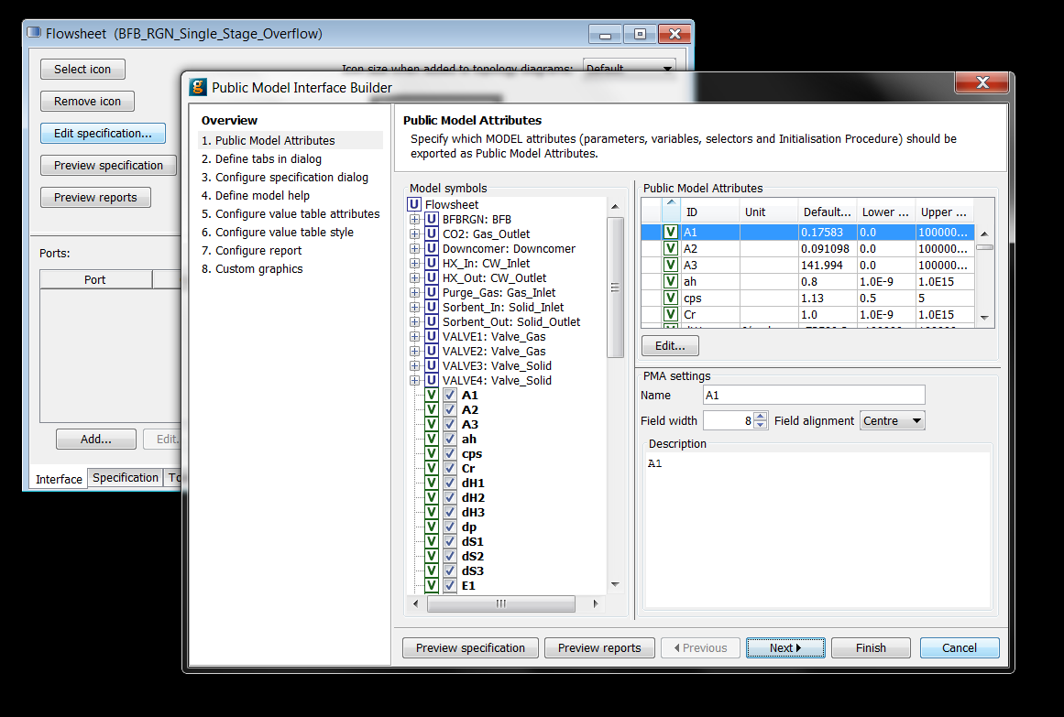

Figure : gPROMS flowsheet variable input parameter specification interface.

Model Initialization

Due to the complexity of the model equations, it is necessary to initialize the model to successfully obtain a solution. The presolved cases have already been initialized and a variable set saved as a starting point for future simulations. It is recommended to start from one of these simulations when developing cases, as it can be difficult to initialize the model from its default state.

In cases where it is not possible to use an existing, pre-initialized model, the BFB model comes with two initialization procedures, defined within the model code, to initialize the model from its default state. These work by starting with a simplified form of the model and gradually adding complexity until the full model is solved. Due to differences in the behavior of the model under adsorption and regeneration conditions, there are initialization scripts for both conditions, which differ in the order in which complexity is added.

It is also important to note that the initialization can be extremely sensitive to the operating conditions being used, and that it may be necessary to adjust the initialization procedures in these cases. This requires an understanding of gPROMS coding in addition to the model code, and the user is directed to the gPROMS User Manuals for more information on this topic. It is for this reason that it is recommended to work from a solved case of the model wherever possible.

To improve the chances of successfully initializing the model, it is suggested to use Run Mode Selectors to simplify the model prior to initializations. The suggested settings are:

* *RM_HXMethod* – either *Condensing* or *Liquid* depending on the state of the HX fluid. **Note:** When using *Condensing* the flowrate of HX fluid must be set to a free variable by clearing the “Flowrate” check box in the HX Fluid inlet in the “Flowsheet” entity.
* RM_MBalance – Simplified
* RM_PhysProp – Simplified
* RM_SmoothIF – Smooth

Once the model has been successfully initialized, the Run Mode Selectors can be returned to the user’s desired settings. If the user is still having difficulty initializing the model, check the Equation Scaling Parameters and set them all to “1.”

Execution of initialization procedures is performed during the execution of a simulation, as described in the next section.

Specifying new initialization procedures in gPROMS requires familiarity with the gPROMS language and environment, thus users wishing to develop more complex models are directed to the gPROMS User Manuals for a more comprehensive discussion. The existing initialization procedures in the presolved cases can be used as starting examples.

Running Simulations

Execution of a simulation run can be done by clicking “Simulate Model Flowsheet” () in the menu bar either from the “Flowsheet” model window from before, or by selecting “Flowsheet”from either the “Models” or “Processes” branches of the simulation tree in the left pane of the “gPROMS” window. Clicking  opens a new “Simulate” window, as shown in Figure 10. In the “Simulate” window, optionally specify a name for the simulation run in the “Case name” text box to easily identify specific simulation runs.

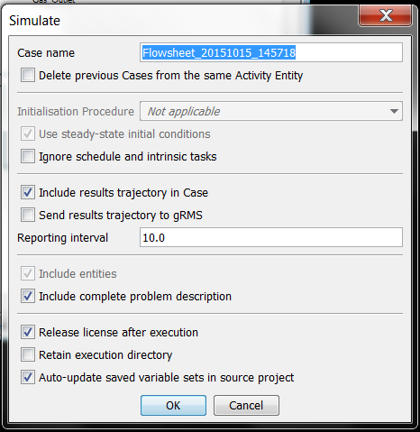

Figure : gPROMS “Simulate” window.

By default, gPROMS runs an initialization procedure if one is present, which includes the provided Steady State cases of the BFB model. In these cases the “Initialisation Procedure” section of the “Simulate”window are not greyed out and the user has the option of executing the initialisation procedure before proceeding with the main simulation. To run the model without using the initialisation procedure (recommended, see the previous section), select the “Ignore” option from the drop-down list beside “Initialisation Procedure.”

Prior to executing a simulation, the user can chose to export the results of the simulation to gPROMS inbuilt plotting software, gRMS. If the user desires to do this, select the “Send results trajectory to gRMS” check box.

Specifying Schedules for Dynamic Simulations

For dynamic simulations, it is also necessary to specify a simulation duration and any scheduled events that are to occur during the simulation. The example cases come with a number of example disturbances (simple ramp changes in input parameters) pre-coded for the user.

In gPROMS, this is done within the model code within a “Process” entity. To access the “Process” entity for the example cases, expand the “Processes” tab of the simulation tree in the left pane of the “gPROMS” window and then double-click “Flowsheet” (the green icon) to open the “Flowsheet” process entity. On the “gPROMS Language” tab, scroll down to the “SCHEDULE” section (line 257) and then examine the various example cases provided. Different cases can be activated and deactivate by commenting out the relevant section of code by surrounding it by braces, {}. By default, only the first case is active.

Running the Simulation

Once the desired run options have been selected, the simulation can be executed by clicking “OK” in the “Simulate” window.

Reviewing Results

Reviewing Results within gPROMS

To access the results of a simulation within gPROMS, expand the “results tree” created by the simulation run in the left pane of the “gPROMS” window, and then expand the “Trajectories” and “Flowsheet” branches, as shown in Figure 11.

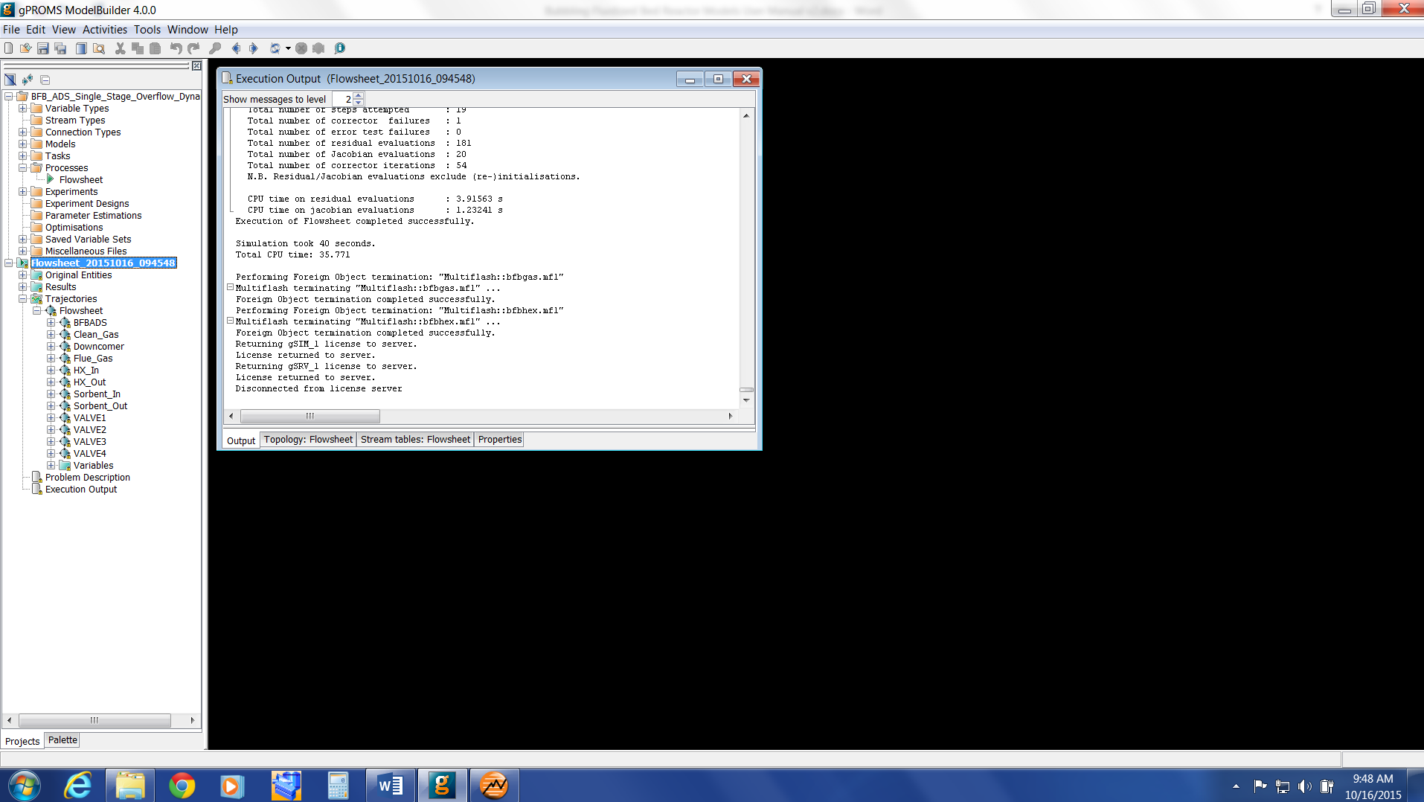

Figure : gPROMS simulation results tree.

Each entity within the flowsheet model, such as reactors, values, inlets, and outlets, has an entry within this tree. The results of a simulation can be accessed by opening the relevant entity and double-clicking the desired variable to obtain the values of that variable from the simulation.

Reviewing Results in gRMS

If the user selected the option to export the simulation results to gRMS, then a new window opens on the desktop. To create a new plot window, click “2D” () in the top left of the window. To add a new plot line to the current plot, click “Add New Line” () in the menu bar. A new window opens displaying the variable explorer tree, similar to that in the gPROMS results tree. Navigate through the tree to select the desired variable to plot and then click “Add.” A dialogue box displays which presents options for naming the variable on the plot, and for selecting what variable use for the x-axis (generally time or discretization point for the BFB model). **Note:** For plots along the axial domain of the model, results will generally be presented in terms of discretization point rather than bed depth, which may result in apparent discontinuities in the plots when using non-uniform discretization schemes.

1. Discretisation Study

To model the variation in conditions along the axial domain of the reactor, the BFB reactor model utilizes numerical approximations to the axial derivatives at discrete locations along the length of the axial domain. The derivatives are approximated using a first order backwards finite difference method, calculated at a defined number of points, “ND,” along the axial domain. Thus, the number and location of these points are key factors in determining the accuracy of the model.

The number of discretization points used in the model, “ND,” is important as it governs the accuracy of the numerical approximations to the true derivatives. As “ND” is increased, the spacing between the point decreases, and the approximations tend towards the true value of the derivatives. However, increasing “ND” also increases the number of equations that must be solved proportionally, increasing the computation demands of the model. Thus, there is a tradeoff between accuracy and complexity.

The accuracy of the numerical approximations to the derivatives is also dependent on the magnitude of the derivatives themselves (or more correctly, upon the rate at which the derivatives are changing (i.e., higher order derivatives)). In areas where the magnitude of the derivatives are large, the rate at which the derivative vary across the axial domain also tends to be large, thus the accuracy of the numerical approximations tends to be lower than for an area where the derivatives are smaller. From this, it can be seen that the benefit of increasing the number of discretization points is more significant in areas where the magnitude of derivatives are larger than in areas where the magnitude is smaller.

This leads to the use of non-uniform discretization schemes, which endeavor to place a greater number of discretization points in areas where the magnitude of the derivatives are larger, and fewer points where the magnitudes are smaller. The BFB reactor model contains implementations of three different discretization schemes for the user to choose from, offering different levels of accuracy and complexity.

The simplest discretization scheme available is a *Uniform* discretization scheme, where all the discretization points are uniformly distributed across the axial domain. This discretization scheme has only one parameter – the number of discretization points, “ND.”

A *2 Stage* discretization scheme is also available, which divides the axial domain into two stages, with different spacings of discretization points in each section. This allows the user to use a greater number of discretization points in the lower portion of the fluidized bed, where the reaction rates, and thus derivatives, are greater. Properly configured, this provides a significant increase in the accuracy of the model for the same number of discrete points, and no increase in the computational requirements of the model.

The *2 Stage* discretization scheme has three parameters which define the distribution of discretization points:

* the number of discretization points, “ND,”
* the fraction of discretization points that occur within the first stage of the domain, “Dis_Split_Frac,”
* the fractional location of the transition between the first and second stages of the domain, “Dis_Split_Loc.”

For example, if *ND* = 100, *Dis_Split_Frac* = 0.5, and *Dis_Split_Loc* = 0.2, then half of the discretization points (i.e., 50 points) will be placed within the first 20% of the axial domain, with the remaining 50 points placed over the remaining 80% of the domain. Thus, the spacing of points in the first stage of the domain will be ¼ of that in the second stage of the domain.

The final discretization scheme available is an *Adaptive* discretization scheme. In this scheme, the spacing of discrete points is inversely proportional to the axial derivative of the CO2 concentration, according to the following equation:

Here, is the length of discrete element , is the length of the axial domain (bed depth), is the axial derivative of the CO2 concentration at point , and is a weighting parameter which controls the uniformity of the discretisation scheme. The advantage of the *Adaptive* discretisation scheme is that it automatically focusses discretisation points to regions where the magnitude of the derivatives are large, and can adapt to changes in conditions in the system without input from the user. However, as the spacing of the discrete points needs to be solved as part of the model, the computational complexity is increased. Additionally, the *Adaptive* scheme is not suitable for *Dynamic* simulations, as the discrete points are able to move during the simulation, which will cause discontinuities in the state variables. The *Adaptive* discretisation scheme has two model parameters which govern the distribution of the discretisation points:

* the number of discretization points, “ND,”
* the weighting parameter ( in the equation above), “Dis_Adpt_Wgt.”

The value of the weighting parameter controls the uniformity of the discretization scheme by balancing the contribution of the derivative term in the calculation of the spacing of the discrete points. A large value of *Dis_Adpt_Wgt* (>1x106) results in a more uniform spacing of the discrete points, and the weighting term dominates the equation, whilst smaller values result in more focus on the areas with high magnitude derivatives. It must be noted that if *Dis_Adpt_Wgt* is decreased too far (approximately <1000), the accuracy of the model begins to decrease as the discretization focused too much on the areas with high magnitude derivatives at the expense of the rest of the domain.

* 1. Study Conditions

To demonstrate the effect of the different discretization parameters on the model predictions, a study of the predictions of the model using different discretization schemes was used. The conditions used in the study were based on a single bed with typical inlet conditions:

* Inlet Gas: 8300 kmol/hr, 68°C, 13% CO2, 5.7% H2O,
* Outlet Gas: 1 bar,
* Inlet Solids: 669,000 kg/hr, 70°C, 0.13 mol bicarbonate/kg, 0.68 mol carbamate/kg,   
  0.31mol H2O/kg,
* Reactor: 12.4 m diameter, 4 m bed depth, 3355 heat exchanger tubes (17.5 mm diameter), Bottom feed, Overflow outlet.

A series of simulations were run varying the number of discretization points, “ND,” between 10 and 102. Values for the remaining discretization parameters (*Dis_Adpt_Wgt*, *Dis_Split_Frac*, *Dis_Split_Loc*) were determined for each simulation by finding the values that resulted in the maximum predicted CO2 removal for the given number of discretization points. It was found that the optimum values were:

* Dis_Adpt_Wgt = 1400
* Dis_Split_Frac = 0.51
* Dis_Split_Loc = 0.22

**Note:** These optimum values were determined for the system studied, and may vary for other reactor conditions (most significantly *Dis_Split_Frac* and *Dis_Split_Loc*).

Figure 12 shows the effect of varying the number of discretization points on the predicted removal of CO2 from the gas stream using the three different discretization schemes. As can be seen, both the *2 Stage* and *Adaptive* schemes give a significant improvement in the accuracy of the model predictions over the *Uniform* discretization scheme (as demonstrated by the approach to the limit as *ND* increases), especially with few discretization points. However, the difference in accuracy between the *2 Stage* and *Adaptive* schemes is generally small, except at the lowest number of discretization points.

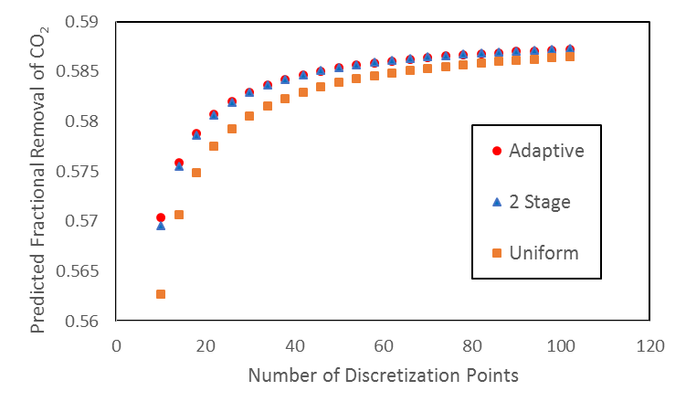

Figure : Dependence of CO2 removal on number of discretization points.

The results shown in Figure 12 suggest that using one of the more advanced discretization schemes would allow the user to achieve the same degree of accuracy in the model using fewer discretization points, thus reducing the computational demands of the model. However, Figure 13 shows the predicted inlet pressure of the reactor as a function of varying the number of discretization points for the three different discretization schemes. Here it can be seen that the predicted inlet pressure is primarily dependent upon the number of discretization points, and that the discretization scheme has a negligible influence on the results. Thus, using a more advanced discretization scheme cannot offset the loss of accuracy incurred by reducing the number of discretization points when it comes to predicting the inlet pressure.

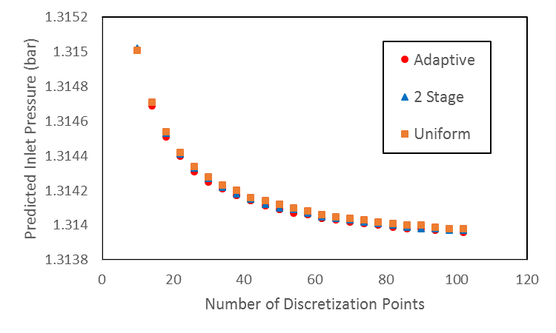

Figure : Dependence of predicted inlet pressure on number of discretization points.

* 1. Summary
* The accuracy of the model is dependent on the number of discretization points used.
* More advanced discretization schemes can improve the accuracy of the predictions regarding the CO2 removal, but the predicted bed inlet pressure is dependent primarily on the number of discretization points.
* Both the *2 Stage* and *Adaptive* discretization schemes perform better than the *Uniform* discretization scheme.
* The results of the *2 Stage* discretization scheme are comparable to those of the *Adaptive* discretization scheme when parameters are optimized, whilst the computational requirements are lower.
* The *Adaptive* discretization scheme is more responsive to change in model conditions than the   
  *2 Stage* discretization scheme without user action, thus may provide better results when significant changes in simulated conditions are expected.

1. Changing Reaction Kinetics

The example models provided contain a kinetic model derived for the solid sorbent NETL32D developed by the CCSI team. For users wishing to study other sorbents, it is necessary to modify the model code to incorporate the relevant reaction kinetics. Due to the wide range of different reactions kinetics that could be considered, this section will give a general overview of how the reaction kinetics are incorporated into the model and the steps necessary to incorporate different kinetics in the future.

Modifying the reaction kinetics necessitates a good understanding of the model code and the modelling language being used. For more details of the modelling languages and the details on the necessary task, users are directed to the User Manuals for the modelling package being used.

Component Lists

The BFB model uses two component lists within the fluidized bed, namely *GasList* for the gaseous species and *AdsList* for the adsorbed species. For users wishing to model systems with species not considered in the current system, it is necessary to add these species to the relevant component lists. The adsorbed species component list, *AdsList*, is a simple string array, and can be simply modified by adding or removing components. On the other hand, *GasList* links directly to the physical properties package incorporated in the modelling package, thus new components need to be added through the physical properties interface.

Thermodynamics and Rate Expressions

The reaction kinetics are modelled using standard rate expressions involving kinetic and equilibrium constants, which are defined as functions of temperature. The relevant code for these calculations is located at lines 1042–1067 in ACM or lines 1228–1253 in gPROMS. In this section of code, three reactions are considered, numbered 1–3. Due to differing conditions between regions, kinetic and equilibrium constants are calculated for each reaction in the cloud-wake and emulsion regions separately. Thus, the first block of code calculates the 6 rate constants for the system (3 reactions x 2 regions) using an Arrhenius type expression. Similarly, the second block of code calculates the six equilibrium constants.

The third block of code calculates the rates of reaction for each of the six reactions, based on the rate expressions from the kinetic model. The reaction rates are based on the solid (adsorbed) phase and are in units of mol/m3.s (volume of solid particles).

Users may easily change these blocks of code to suit their purposes, adding, removing, or modifying equations as needed for the specific reaction kinetics.

Connecting Rate Expressions to Mass Balances

The rate expressions discussed above are all written in terms of specific reactions, not individual components. The next section of the code connects the rate expressions for each reaction to the net rate of reaction for each component via stoichiometry. The relevant lines of code are lines 1069–1095 in ACM and lines 1256–1293 in gPROMS.

The first lines of code calculate the net rate of reaction of each gas species in *GasList* from the rate expressions for each reaction. **Note:** The gas phase reaction rates have units of kmol/m3.s (as opposed to mol/m3.s for the rate expressions), thus the unit conversion factor of 1000. The next section of code does the same thing for the adsorbed species in *AdsList*, which does not require a unit conversion.

Sorbent Enthalpy

The final block of code within the reaction kinetics section estimates the enthalpy of solids with adsorbed species. As this is often poorly characterized the BFB model approximates this using the method of Walton and LeVan [4]. The specific enthalpy of the sorbent with adsorbed species is assumed to consist of three independent parts:

1. The specific enthalpy of the sorbent, currently modelled using a constant heat capacity.
2. The net heat of reaction for each reaction. This is the total amount of species reacted via each reaction, including any that reacts further via another reaction, multiplied by the heat of reaction.
3. The specific enthalpy of the adsorbed solids. This is approximated by determining the total amount of each gas species required to form the adsorbed species present, and using the gas phase heat capacity of these species (and the conditions of the solids) to approximate the specific enthalpy of the adsorbed species.

Users should be careful when incorporating different kinetics to ensure that these calculations are correct, and that all terms in the enthalpy approximation are accounted for correctly.

1. Installation Requirements

The minimum suggested hardware requirement is desktop/laptop running Windows® 7 on Intel Core i-5 family 2.8 GHz or faster and 8 GB of RAM. With lower configuration, the simulation speed can be slower. The ACM and gPROMS models have been tested on Aspen V8.4 and gPROMS ModelBuilder 4.0, respectively.

1. References

[1] Lee, A., Mebane, D.S., Fauth, D.J., and Miller, D.C., “A Model for the Adsorption Kinetics of CO2 on Amine-Impregnated Mesoporous Sorbents in the Presence of Water,ˮ Pittsburgh Coal Conference, 2011.

[2] Lee, A., and Miller, D.C., “A One-Dimensional (1-D) Three-Region Model for a Bubbling Fluidized-Bed Adsorber,ˮ *Industrial & Engineering Chemistry Research*, 2013, 52 (1), 469–484.

[3] Modekurti, S., Bhattacharyya, D., and Zitney, S., “Dynamic Modeling and Control Studies of a Two-Stage Bubbling Bed Adsorber-Reactor for Solid-Sorbent CO2 Capture,ˮ *Industrial & Engineering Chemistry Research*, 2013, 52, 10250–10260.

[4] Walton, K., and LeVan, M.D., *Consistency of Energy and Material Balances for Bidisperse Particles in Fixed-Bed Adsorption and Related Applications*, Ind. Eng. Chem. Res., 2003, 42,   
pg. 6938–6948.